Issue Brief: Regenerative Agriculture Regenerative AgricultureNSERT TOPIC NAME HERE]

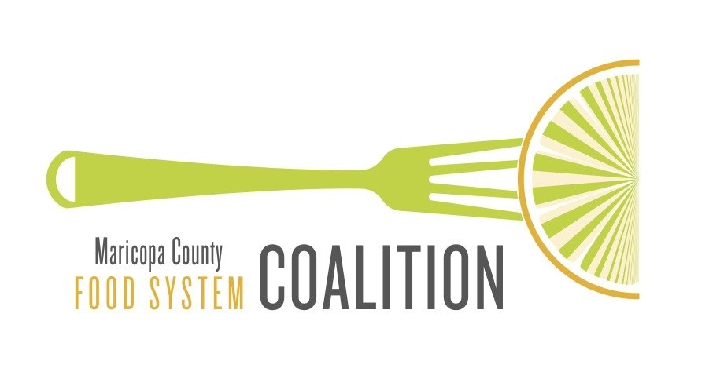

MarCo Issue Brief – February 2022

Introduction

Regenerative Agriculture

Regenerative Agriculture at its most fundamental level is working with, or as, Nature. The concept of Regenerative Agriculture and its strict definition is particular to the perspective taken.

The Indigenous Roots of Regeneration

From an Indigenous perspective, regenerative agriculture is a way of being, a way of thinking, a way of interacting, working with, learning from, and ensuring that we become one with the ecosystems so that we can regenerate ourselves and other living creatures .

Holistic Land Management

Regenerative agriculture as part of a holistic land management practice centers around building and maintaining healthy soil, primarily through practices that increase soil organic matter. Healthy soil increases biodiversity, builds crop resiliency, infiltrates & holds water, and leads to more nutrient dense food. One teaspoon of healthy soil contains more living organisms than there are people in the world. It is a living universe that feeds the food we eat.

Regenerative Agriculture practices include:
- Careful observation of ecosystems
- Cover crops, mulch
- Crop rotations
- Minimizing soil disturbances
- Reduced or no tillage
- No fertilizer or pesticide use/synthetic inputs
- Promoting biodiversity
- Managed & adaptive grazing
- Livestock integration

Soil Health

Healthy soils produce healthy crops that in turn nourish people and animals. Soil quality is directly linked to food quality and nutrient density.

There are 6 Principles of Soil Health:
- Know Your Context – ecological, community, economic, and spiritual contexts
- Do Not Disturb – no mechanical (tilling) or chemical disturbances
- Cover and Build Surface Armor – protect the surface, or skin, of the soil
- Mix It Up – create a diversity of plants, crops, insects, microbes, wildlife, and livestock
- Keep Living Roots in the Soil – roots nourish microbes which feed plants
- Grow Healthy Soils and Animals Together - ecosystem heath is accomplished through synergistic relationships

Climate Resiliency – Managing Land

Regenerative agriculture promotes key factors that contribute to a land’s resiliency to climate and weather, such as:
- Building-up healthy soil biology
- Improving soil aggregate structure
- Promoting plant species diversity
- Proper integration of animals through adaptive grazing
Practices that build healthy soils leads to healthy, resilient land that can withstand climate impacts like heat, drought, and flooding.

Carbon Sequestration

It is not only possible to increase the amount of soil organic carbon in existing soils, but also to build new soil. This has the effect of sequestering carbon. Regenerative agriculture balances the carbon in the atmosphere by bringing it back and putting it in the soil where it can generate wealth by building the health of the soil and the food we grow. And, ultimately, of entire ecosystems.

Regenerative Agriculture is Life

At the heart of regenerative agriculture is how to nurture, restore, diversify, and support life—life between people, life in soils, life for animals, and life as caretakers of land and other living beings.

Farmers and ranchers adopting regenerative practices recognize this essential relationship with life. As consumers we can demand and purchase food (plants and animals) that is grown and raised in a regenerative manner by local growers.

Regenerative Seals & Farm Map

To help highlight and acknowledge those practicing regenerative agriculture, several seal certifications programs and regenerative farm locator maps have been developed. Intertribal Agriculture Council (IAC) & Rege[N]ation

The IAC Rege[N]ation Pledge and Seal is exclusively available to Native American and Alaskan Native agriculturalists -- from farmers, ranchers to harvesters and foragers-- who pledge to abide by the conditions laid out in the certification process. Land to Market

Land to Market advertises itself as the world's first verified regenerative sourcing solution for meat, diary, wool, and leather. Regenerative Organic Certified (ROC)

A certification for food, textiles, and personal care ingredients.
Resources

Regenerative Agriculture Alliance
https://www.regenagalliance.org/

Indigenous Re-Generation
https://www.indigenousregeneration.org/

Regenerative Agriculture: A decolonization and indigenization framework
https://www.regenagalliance.org/blog/regenerative-agriculture-a-decolonization-and-indigenization-framework

Regeneration International https://regenerationinternational.org/

Understanding Ag, LLC
https://understandingag.com/

Soil Health Principles with Context
https://understandingag.com/soil-health-principles-with-context/

Healthy Soils are the Basis for Health Food Production
https://www.fao.org/soils-2015/news/news-detail/en/c/277682/

Fixing the Water Cycle: Managing Soils for Water Efficiency
https://organicfarmermag.com/2020/07/fixing-the-water-cycle-managing-soils-for-water-efficiency/

The Imperative for Regenerative Agriculture https://journals.sagepub.com/doi/pdf/10.3184/003685017X14876775256165

Regenerative Agriculture for Food and Climate
https://www.jswconline.org/content/75/5/123A.full

Growing Resilience Through Regenerative Agriculture
https://understandingag.com/growing-resilience-through-regenerative-agriculture/

Savory Institute
https://savory.global/

Rege[N]ation Pledge and Seal
https://www.indianag.org/regenation

Made/Produced by American Indians Directory
https://www.indianagfoods.org/producers

Land to Market Regenerative Agriculture Seal
https://savory.global/land-to-market/

