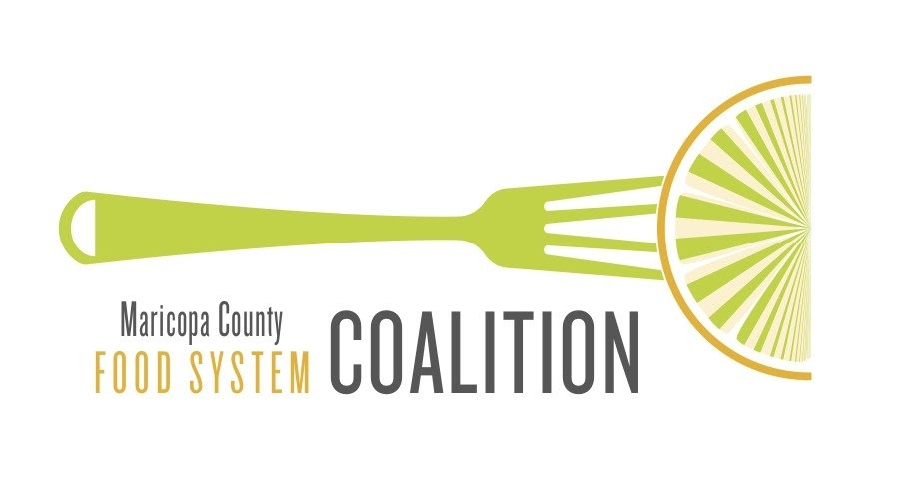
Issue Brief: Water Access

MarCo Issue Brief – January 2022

Introduction: Water Access

History
Water is deeply rooted in the history of Arizona. As early as 300 BCE (to 1450 AD), the Hohokam peoples began to develop a robust agricultural operation across the region, building a network of over 500 miles of irrigation canals by hand. These canals are the backbone for the modern-day canal system, still serving the region.⁽¹⁾

The Hohokam peoples were succeeded by the Akimel O’odham, who allied with the Piipaash tribe with whom they shared space, resources and continued to develop irrigation systems for agriculture. After the Gadsden Purchase in 1854, American settlers arrived and diverted water from the Gila River that supported native agriculture⁽²⁾. This resulted in a loss of self-reliance and mass starvation. By 1883, the Akimel O’odham and Piipaash tribes were confined to the Gila River Indian Community and Salt River Pima-Maricopa Indian Community reservations.⁽¹⁾

With an increasing population and agricultural water demands on the rise, settlers were facing a drought by the late 1800’s. To secure greater water access, ranchers and farmers banded together to put their newly “attained” land up as collateral for federal financing through the National Reclamation Act. In 1903, the Salt River Valley Water Users’ Association was formed, now known as the Salt River Project or SRP⁽²⁾. SRP maintains the waterways and distribution of water, which includes 7 dams and 131 miles of canals that deliver water from the Verde and Salt Rivers to the Valley⁽²⁾.
In 1922, Arizona, California, Colorado, Nevada, New Mexico, Utah, and Wyoming entered into the Colorado River Compact to safeguard access to Colorado River water. With a continued influx of settlers, farmers drilled wells to access groundwater which unregulated and resulted in a major depletion of groundwater. In 1973, the Central Arizona Project (CAP) Aqueduct broke ground to divert Colorado River water to the Phoenix and Tucson metro areas to reduce the reliance on groundwater. for agriculture and other activities, the CAP delivers water to municipal, agricultural and indigenous communities through a 336 mile aqueduct Tucson.⁽³⁾
To protect groundwater resources, the 1980 Groundwater Management Act was passed to regulate the use of groundwater in newly established Active Management Areas (AMAs)⁽⁴⁾. The Gila River Indian Community(GRIC) pursued legal action against the U.S. government and through the Arizona Water Settlements Act of 2004 the Gila River Indian Community was guaranteed the right to water and provided funding for infrastructure to utilize their guaranteed water allocation, which is primarily from the CAP⁽⁵⁾.

Current Water Use
Agriculture Use - Water is one of the most critical resources for food production. Farmers in Maricopa County use a combination of three main water sources, and a lesser used fourth:

- Groundwater
- Colorado River water through the CAP
- Surface water from SRP
- Effluent or reclaimed water, a small percentage of total water use

Water sources that a farmer uses is based primarily on the parcel’s proximity to surface water sources and the CAP. For example, East Valley farms tend to irrigate with surface water, while West Valley farms depend largely on groundwater.

Maricopa County has seen a decline in agriculture water use that correlates with farmland transiting to urban uses. As the population increases, more land transitions to other types of development (e.g., housing, businesses).

Despite these threats, many farmers interviewed for MarCO’s Community Food Assessment reported having ample water access at the time - typically the land they farm has secured assured rights. However, farmers losing the ability to farm as it becomes appealing for landowners to sell to developers.

Individual Use - In metro Phoenix, the average person consumed 115 gallons of water per day in 2018⁽⁸⁾. Down from 135 in 2005, but well above Tucson’s average of less than 85 gallons per day⁽⁹⁾. Phoenix’s water prices are among the lowest in the country⁽⁶⁾. The Valley only experiences an average of 8 inches of rain a year⁽¹⁰⁾. Water use ordinances to limit individual water use do not currently exist, but rather water conservation websites, reports on optimizing water systems⁽¹¹⁾, rebate rebates⁽¹²⁾, incentive programs⁽¹³⁾, and xeriscape workshops are utilized.

The Future of Water

In August 2021, Federal officials declared the first ever water shortage on the Colorado River. This shortage will result in an 18% reduction in Colorado River water for Arizona beginning in 2022. This will primarily impact farmers in Pinal County⁽¹³⁾. Farmers have been aware for two decades ago of the potential loss of CAP water if there is a shortage. Scientists and policymakers are concerned about reverting back to pumping groundwater that could lead to the same issue that CAP had briefly solved: the overdraft of 769 billion gallons of groundwater each year⁽¹³⁾.

As for individual use - it depends on the city you live in. Most homeowners in Maricopa, Pima and Pinal counties won’t see a significant difference in tap water. According to Chuck Cullom, Colorado River Programs Manager with CAP, "Depending on the city, they may see a very minor increase in their water rates, but overall, 2022 will look very similar to a homeowner in Gilbert to 2021.” ⁽¹⁴⁾

The Future of Water
https://storymaps.arcgis.com/stories/a1a782ce054d4ad28a0d7d0845e6c03d?utm_campaign=ASU_Morrison_Colorado+River+Shortage+Story+Map+Email_4238461&utm_medium=email&utm_source=ASU_Morrison_SFMCE&utm_term=ASU&utm_content=Button+to+story+map&ecd42=518001255&ecd73=258953875

Resources

1 Gila River Indian Community. 2007. Animal O’Odham - Piipaash: Our Community Our Future.

2 Salt River Project. 2017. The Story of SRP: Water, Power, and Community. Retrieved from: https://www.srpnet.com/about/ history/StoryofSRP_HistoryBook.pdf

3 CAP: Background & History. 2016. Retrieved from: https://www.cap-az.com/about-us/ background 8 Arizona Department of Water Resources (ADWR). 2010. Arizona Water Atlas. Volume

4: Active Management Areas Water Atlas. Retrieved from https://infoshare.azwater.gov/docushare/dsweb/Get/Document-10433/Volume_8_final.pdf 9 Gila River Indian Community. 2007. DeJong D. 2014.

5 Navigating the Maze: The Gila River Indian Community Water Settlement Act of 2004 and Administrative Challenges. American Indian Quarterly. Winter. vol. 38, no. 1.

6. https://www.phoenix.gov/waterservicessite/MediaAssets/WSD%20Home%20Page/EquityPaper_2020-06-23_Final.pdf

7
https://www.bv.com/sites/default/files/2019-10/50_Largest_Cities_Rate_Survey_2018_2019_Report.pdf

8 https://morrisoninstitute.asu.edu/sites/default/files/sun_corridor_2021_final.pdf

9
https://www.theguardian.com/us-news/2021/apr/05/arizona-water-one-percenters

10
https://www.theguardian.com/us-news/2021/apr/05/arizona-water-one-percenters

11
https://www.tempe.gov/home/showpublisheddocument?id=85554

12
https://www.tempe.gov/government/municipal-utilities/water/water-conservation/rebates/high-efficiency-turf-irrigation

13
https://www.buzzfeednews.com/article/caitochs/colorado-river-shortage-arizona-drought

14
https://www.azfamily.com/weather/arizona_drought/arizonas-water-supply-to-face-cuts-after-water-shortage-declaration-issued/article_6e62c93e-fec7-11eb-b086-0fd227ea946a.html

