Issue Brief: FOOD SECURITY

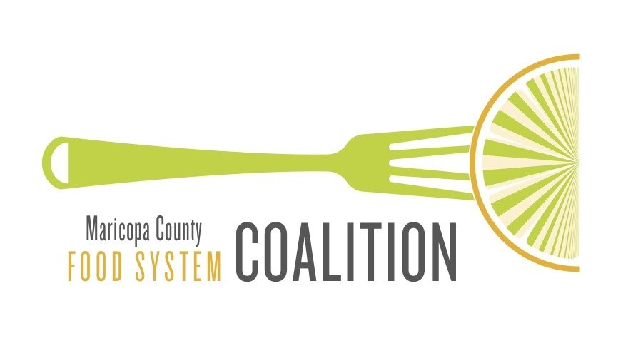

MarCo Policy Work Group - June 2021
Introduction

Food Security

Food security is defined as existing when all people, at all times, have physical, social and economic access to sufficient, safe and nutritious food that meets their dietary needs and food preferences for an active and healthy life.

There are four major components of food security:

- Food availability – the “supply side” of food security, often determined by food production, stock levels, and net trade.
- Food access – whether one has adequate resources to obtain food for and is often related to income, physical access to food, and the cost of food.
- Food utilization – if food being consumed by individuals promotes health and well-being.
- Food stability – how consistent and adequate the other three components are.

Maricopa County: Food Availability

Food availability is currently not a challenge in Maricopa County as evidenced by the copious amount of food surplus and waste. However, food system planners should plan cautiously to ensure that there is enough food in the future as they are faced with resource scarcity and infrastructure challenges.

Maricopa County is a national leader in several vegetable, fruit and forage crops. While it is unknown what proportion of food consumed is grown locally, future production may be challenged by the increasing scarcity of resources such as land and water. To compensate for these trends and harsh climatic conditions, the State of Arizona imports many agricultural products. Because of proximity, fruit and vegetable products are imported from Mexico and other South American countries.

Food system stakeholders in Maricopa County have expressed concern over the shortage of food processing facilities in the county as they are a crucial component of the agri-food system. Generally, as the number of producers decrease, so do processing facilities, i.e., elimination of citrus processing sheds as citrus groves have transitioned to urban development. This phenomena makes it difficult for smaller farms to sustain themselves.

Maricopa County: Food Access

Despite the abundance of food, both adults (11.7%) and children (16.3%) in Maricopa County have food insecurity rates higher than the national average. Several factors such as income, cost of food and physical access to food can impact a household or individual’s ability to obtain food.
First, 12.2% of residents in Maricopa County live below the poverty line. Often those who do not have a sufficient income are unable to purchase the types and quantities of food they need. According to Feeding America, the cost of a meal in Maricopa County is $3.25, which is higher than the U.S. average of $3.13. Programs such as SNAP (Supplemental Nutrition Assistance Program) were created to aid low-income households and individuals in overcoming these barriers but may be challenging to obtain as only 76% of eligible Arizona residents participate.

Residents also face challenges to physically obtaining food. Low income neighborhoods in Maricopa County, particularly Phoenix, are “food deserts”. Food deserts are areas where urban residents are more than 1 mile (10 miles for rural residents) from affordable, healthy food and where more than 20% of the population lives in poverty.

Maricopa County: Food Utilization

Food Utilization is the least understood and measured component of food security and is related to both the healthfulness and the social value of food.

Even if food is available and accessible, it may not promote the wellbeing of individuals and households. Because Maricopa County has high rates of diet related disease, there is reason to be concerned about the type and quality of food that is available and accessible. While many residents express that they value high quality healthful foods, they may not be located conveniently or priced affordably.

Additionally, those with dietary needs or food preferences may struggle to obtain the kinds of food they need. It is also important that residents can consume foods that meet their social and cultural needs. Maricopa County is diverse and requires food options that meet the needs of different cultural and ethnic groups.

From Food to Nutrition Security

As issues of malnutrition have gained attention, food and nutrition communities have begun to place more emphasis on the “utilization” component of food security. Even though an increasing number of people are consuming enough food to relieve hunger, they are not always consuming foods that fulfil physiological nutritional requirements. Though the concept of food security currently includes components of nutrition and utilization, some there has been a shift to using the term “nutrition security” because it may describe the U.S. food system goals more accurately.

Resources

Cantrell, C. and Lewis, R. Food System Infrastructure: Michigan Good Food Work Group Report No. 5 of 5. East Lansing, MI: C.S. Mott Group for Sustainable Food Systems at Michigan State University. (2010). www.michiganfood.org
Center on Budget and Policy Priorities. A closer look at who benefits from SNAP. (2021). https://www.cbpp.org/research/food-assistance/a-closer-look-at-who-benefits-from-snap-state-by-state-fact-sheets#Arizona

City of Pheonix. Environmental Sustainability Goals: Local Food Systems. (2016). https://www.phoenix.gov/sustainability/goal

Ericksen, P. J. Conceptualizing food systems for global environmental change research. Glob. Environ. Chang. 18, 234–245 (2008).

Feeding America. Food Insecurity in Maricopa County. Map the Meal Gap. (2019).
https://map.feedingamerica.org/county/2019/overall/arizona/county/maricopa

Nord M. Characteristics of low-income households with very low food security: An analysis of the USDA GPRA food security indicator. USDA-ERS Economic Information Bulletin No. 25. 2007.
https://www.ers.usda.gov/publications/pub-details/?pubid=44173

Omri, Resch, Gundlach. Food Deserts: Evaluating Grocery Stores and Bus Assessability using GIS in Madison, Wisconsin. (2013).
https://minds.wisconsin.edu/bitstream/handle/1793/73421/Omri%20Resch%20Gundlach.pdf?sequence=1&isAllowed=y

Piser, Karina. Vilsack calls for structural changes in U.S. food distribution systems to heal with hunger, equity. Fern’s Ag Insider. (2021).
https://thefern.org/ag_insider/vilsack-calls-for-structural-changes-in-u-s-food-distribution-systems-to-deal-with-hunger-equity/

University of Arizona Economic and Business Research Center. Arizona-Mexico Economic Indicators. https://azmex.eller.arizona.edu/imports/imports-from-canada

USDA Economic Research Service. Food Access Research atlas. (2019). https://www.ers.usda.gov/data-products/food-access-research-atlas/go-to-the-atlas/

