Issue Brief: COMMUNITY FOOD FORESTS

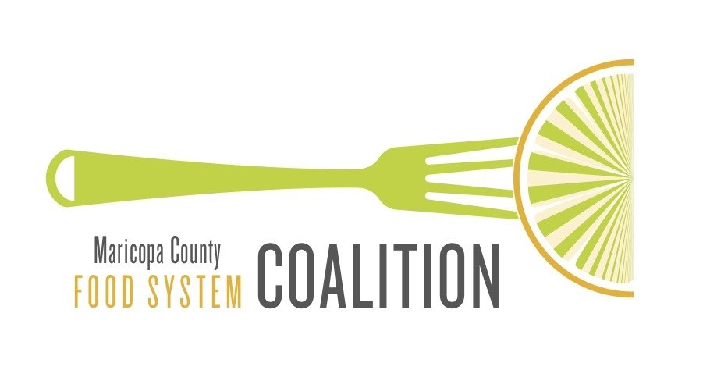

MarCo Issue Brief - September 2021

Introduction

Community Food Forests

In the process of reviewing current literature, it became clear that there is not a consistent definition of food forest. This is the definition commonly used.

A food forest is a permaculture, or self-sufficient, gardening technique that mimics a woodland ecosystem, and they’re popping up in cities all over the United States. Rather than neat rows of annual crops that need to be dug up and replanted each spring, a food forest has layers of mostly perennial edible and medicinal plants. There may be a canopy of fruit trees, below that shrubs like blueberries, then herbs like rosemary, ground-cover crops like clover, as well as vining plants and root vegetables like potatoes. They tend to promote native plants and provide education about sustainable agriculture, beneficial insects, and local foraging. And unlike at many community gardens, a food forest has an open door policy. Anyone can come at any time of day and take whatever they want.

In The Community Food Forest Handbook a primer on community food forests by Catherine Bukowski and John Munsell define food forests as:

“The definition of a community food forest differs depending on whether the focus is on the concept or the physical space. Conceptually, to better understand the meaning embedded in the term community food forest, consider each word: forest, food, and community. Forests are places, but forests become social spaces through physical, cultural, environmental, and emotional connections. One such connection is food, which can bring people together, but others such as dialogue, wildlife, and recreation are also important. When people connect in forested spaces, they shape their social sense of place, values, and identity and create community. Thus, concepts of environment and society are critical pieces of a community food forest because both influence actions like planning, planting, and maintenance that transform ideas into real projects.

An on-the-ground, physical food forest mimics the spatial and functional patterns of a naturally occurring forest ecosystem. Most people think of a forest as a large area, but from a biological standpoint a forest does not have to meet a minimum height or size requirement.

Rather, the term food forest signifies a highly integrated community of plants that has various vertical and horizontal plant and root layers that provide edible products.”

An approach that several major cities have taken is to look on food forest as another tool to be used to address community food and nutrition insecurity. Sari Albornoz, the Grow Local program director for the Sustainable Food Center, an Austin, Texas-based nonprofit organization working to improve access to nutritious, affordable food.

“Food forests are one more idea people are embracing [in addition to programs like SNAP and WIC, encouraging farmers’ markets in food deserts, and increasing minimum wage], because it has the potential to address food insecurity.”

Cities Creating Food Forests

Atlanta - When a dormant pecan farm in the neighborhoods of south Atlanta closed, the land was soon rezoned and earmarked to become townhouses. But when the townhouses never came to fruition and with the lot remaining in foreclosure, Atlanta's Conservation Fund bought it in 2016 to develop an unexpected project: the nation's largest free food forest.

Thanks to a US Forest Service grant and a partnership between the city of Atlanta, the Conservation Fund, and Trees Atlanta, 7.1 acres of land with 2,500 pesticide-free edible and medicinal plants only 10 minutes from Atlanta's airport. The forest is in the Browns Mill neighborhood of southeast Atlanta, where the closest grocery store is a 30-minute bus ride away.

"Access to green space and healthy foods is very important. And that's a part of our mission," says Michael McCord, a certified arborist and expert edible landscaper who helps manage the forest.
The forest is part of the city of Atlanta's larger mission to bring healthy food within half a mile of 85% of Atlanta's 500,000 residents by 2022, though as recently as 2014, it was illegal to grow food on residential lots in the city.

Seattle - Beacon Food Forest is a demonstration site and a learning community that reimagines what urban green spaces can offer.

Volunteers turned a swath of grass into a vibrant, thriving ecosystem that now provides fresh produce, uplifting beauty, pollinator habitat, healthy soils, climate change mitigation, storm water filtration, educational opportunities, and - perhaps most importantly - a community where everyone is welcome to be, participate, learn, and teach.

Beacon Food Forest’s design process, layout and stewardship are based on the design principles and ethics of Permaculture. In September 2012, the first trees were planted. Since then, hundreds of volunteers have contributed to turning the first 1.75 acres into food forest, a giving garden, and P-Patch plots.

Phase 2 broke ground in 2019 adding 1.5 acres of growing and learning space to the site. In 2020, vegetable production was intensified to donate to food banks in response to increased food insecurity in our community due to the economic fallout of the COVID-19 pandemic.

Most of the Beacon Food Forest is an open harvest site which means that anyone can from the site. Users enter into the “community agreement” to take only what they need and always leave some for others. This model has been very successful so far.
Nearly all the produce gets harvested, eliminating food waste as well as fallen fruit that could attract pests.

Resources

Bukowski, C. and Munsell, J. The Community Food Forest Handbook, https://communityfoodforests.com/handbook/

Jodi Helmer, Can Food Forests Fight Hunger? Civil Eats, (2021) https://civileats.com/2019/08/14/can-food-forests-fight-hunger/

Jodi Helmer, Move Over, Community Gardens: Edible Forests Are Sprouting Up Across America, Smithsonian Magazine, (2016), https://www.smithsonianmag.com/arts-culture/move-over-community-gardens-edible-forests-are-sprouting-across-america-180960024/

Carly Ryan, Atlanta Creates the Nation’s Largest Free Food Forest with Hopes of Addressing Food Insecurity, CNN (2021) https://www.cnn.com/2021/02/22/us/atlanta-free-food-forest-trnd/index.html

Hallie Golden, The Beacon Food Forest Grows Community Agriculture in South Seattle, Curbed (2019) https://seattle.curbed.com/2019/1/28/18196269/beacon-food-forest-urban-agriculture

Beacon Food Forest, https://beaconfoodforest.org/about-us

Beacon Food Forest, Seattle Department of Neighborhoods, https://www.seattle.gov/neighborhoods/programs-and-services/p-patch-community-gardening/p-patch-list/beacon-food-forest

Jen Kinney, Planting the Seeds of a Food Forest in Philadelphia, Next City (2018) https://nextcity.org/daily/entry/food-forest-idea-sprouting-roots-in-philadelphia

