Issue Brief: MUNICIPAL TOOLS FOR FARMLAND PRESERVATION

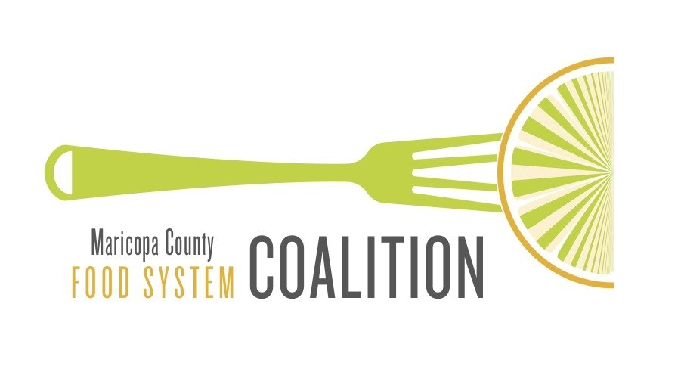

MarCo Issue Brief - September 2021
Introduction
Farmland Preservation

Municipalities (cities/towns) and counties in Arizona have certain powers granted by the legislature for a specific purpose that may or may not have the intent for farmland preservation. The following discussion provides a brief overview of those powers.

Purchase of land; purchase of conservation easements; purchase of development rights.

Land purchase for public facilities:
- Park sites, library sites, public safety facility sites, street rights-of-way and other public uses.
Land purchase for Sonoran Desert preservation:
- Phoenix – Purchase of land to include in the Sonoran Desert Preserve
- Scottsdale – Purchase of land to include in the McDowell Sonoran Preserve
Both cities use voter approved sales tax increases to fund the purchases. The land purchases demonstrate how cities can acquire land for a public purpose.

Land purchase and land leases:
- Pima County – Purchase of land for the Sonoran Desert Conservation Plan.
- Pima County – Lease of Az State Trust Land for the Sonoran Desert Conservation Plan
Pima County used funds approved by voters through a bond election and has partnered with Arizona Land and Water Trust in some acquisitions.

Zoning Regulations - Planned Area Development (PAD) and Planned Unit Development (PUD)

PAD/PUD are zoning tools used to encourage innovative design that allows a developer to cluster residential units so as to retain portions of the development site for amenity uses – parks, open space, stormwater basins. This allows the developer to “transfer” the development rights from a specifically identified “sending” parcel within a proposed development project to a “receiving” parcel(s) in the same project. This action by the developer is generally done in exchange for providing an amenity(ies) within the same development project.
Municipalities and counties can use the PAD/PUD zoning tool to preserve a portion of a proposed development for a variety of amenities including providing an area for growing food. There is a need to have local policies and zoning regulations in place as well as a willingness for collaboration with the development community to encourage farmland preservation.
Example: Agritopia in Gilbert includes 11 acres set aside for food production. Agritopia is zoned as a PAD with the overall concept of an urban agriculture community.
All municipalities and counties can use this zoning tool for farmland preservation.

Transfer of Development Rights (TDR)
Municipalities and counties have been granted the authority to adopt a TDR Ordinance and establish a mechanism for tracking development rights. The TRD tool differs from the PAD/PUD zoning tool in that all or a portion of development rights can be transferred from a sending parcel to a receiving parcel or parcels. The sending and receiving parcels do not need to be adjacent but must be located in the same jurisdiction.
The jurisdiction adopting the TDR Ordinance can identify sending and receiving areas anywhere within the boundaries of the jurisdiction. When a TRD Ordinance is adopted, the jurisdiction must establish a system for tracking the development rights.
Pima County is the only jurisdiction in Arizona that has adopted a TDR Ordinance. The County has used the transfer of development rights as a tool to help limit development in areas the county has targeted for conservation and “transfer” the development rights to areas in the county designated for future growth.
The ordinance allows property owners to swap development rights for cash. Once the development rights have been purchased, depending on what exists on the property and if the property owner is willing, the county acquired the parcel at the reduced price and the land became a park of the conservation area.

Zoning for Urban Agriculture

As currently written, zoning codes frequently restrict or prohibit agricultural activities, especially in residentially zoned areas. Updating zoning codes to reduce restrictions on agricultural uses and provide guidance on proper use has the potential to increase residents’ access to healthy food in the area.

Allowing residents to grow their own food or encouraging small growers to produce food in food-insecure areas can increase access to healthy food. By ensuring that food production is properly regulated and managed, local governments can create a mixed-use land pattern that incentivizes healthy food production in all zones while ensuring community concerns and quality of life issues are addressed.
A crucial step in increasing food access and urban agriculture activities is to remove regulatory barriers that exist in the current zoning code. In addition, cities should consider enabling language to confirm and memorialize which urban agricultural activities are allowed and in which zoning districts.

While zoning codes are often not written to specifically prohibit urban agricultural activities, the absence of express permission may deter potential growers. Cities may make these changes through zoning code amendments or by rewriting and replacing their entire zoning code.

Resources

Seeding the City – Land Use Policies to Promote Urban Agriculture - https://www.changelabsolutions.org/product/seeding-city

Farmland Protection – The Role of Local Governments in Protecting Farmland as a Vital Local Resource - http://growingfoodconnections.org/wp-content/uploads/sites/3/2015/11/GFCPlanningPolicyBrief_FarmlandProtection_2017Sept1.pdf

Zoning for Urban Agriculture: A Guide for Updating Your City’s Laws to Support Healthy Food Production and Access - https://healthyfoodpolicyproject.org/key-issues/zoning-for-urban-agriculture

Planning for Food Access: A National Scan and Evaluation of Local Comprehensive and Sustainability Plans - https://www.planning.org/research/foodaccess/

Growing Urban Agriculture: Equitable Strategies and Policies for Improving Access to Healthy Food and Revitalizing Communities - https://www.policylink.org/resources-tools/growing-urban-agriculture

URBAN FOOD ZONING CODE UPDATE - https://www.portland.gov/bps/food-policy-and-zoning-portland

Agricultural Overlay Zoning - https://sustainablecitycode.org/brief/agricultural-overlay-zoning/

