Issue Brief: EDIBLE LANDSCAPING

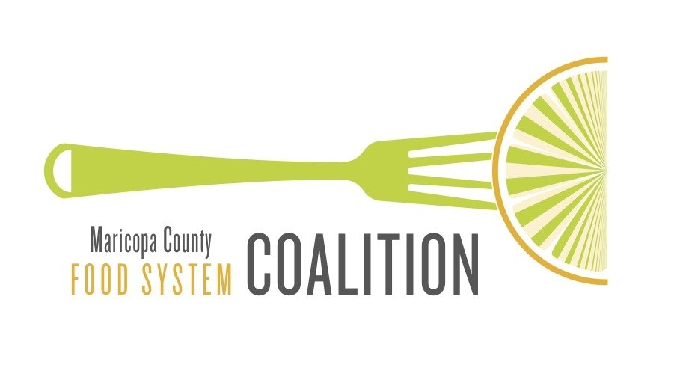

MarCo Issue Brief - September 2021
Introduction

Edible Landscaping

Edible landscaping involves integrating food plants and fruit and nut trees in an ornamental or decorative setting such as homes, housing developments, businesses, streets, and city parks.

Incorporating edibles in landscape design provides a unique landscape design that provides health benefits and economic opportunities as well as beauty. This can also include public community gardens, which are similar to the victory gardens in World War II where parks were used to raise food as part of the war effort.

Land purchase and land leases:
- Pima County – Purchase of land for the Sonoran Desert Conservation Plan.
- Pima County – Lease of Az State Trust Land for the Sonoran Desert Conservation Plan
Pima County used funds approved by voters through a bond election. Partnered with Arizona Land and Water Trust in some acquisitions.

Pros and Cons to Consider

People who live, work, or play in areas of edible landscaping have access to fresh produce without having to travel to a store or farmers market. This also helps reduce food insecurity, provides healthy food options at low or no costs, and provides horticultural therapy for mental health. Fruit trees also provide shade to help offset urban heat islands. Plants in containers can be moved to protect them from high heat or for added flexibility in landscaping design.
Cons
Edible landscaping requires more maintenance and cost, including garden planning for seasonal planting, additional plant waste for disposal, and more water than native desert or desert-adapted plants and trees. Without companion planning, edible landscaping can attract destructive garden pests that need to be eliminated organically or with chemicals.

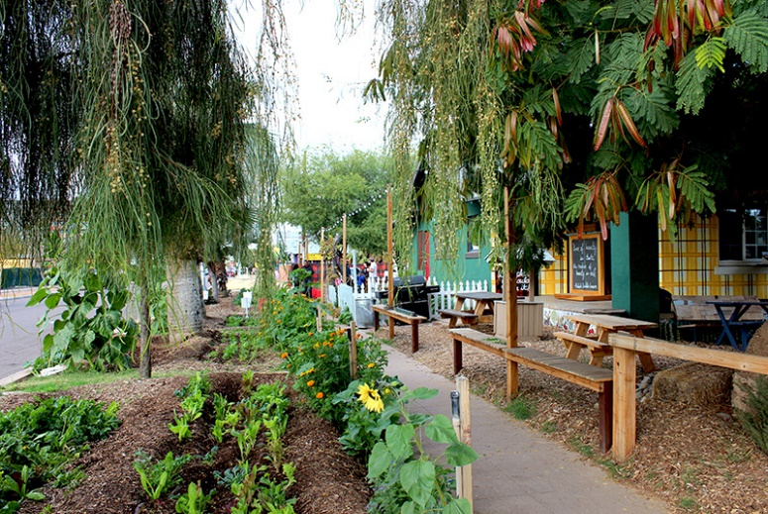
Roosevelt Row garden in right-of-way spaces. Photo by Kenny Barrett.

Planning and Barriers

Planning for edible landscaping in community involves helping governments to see the connections between public health and the need to eliminate barriers to urban agriculture. After identifying ordinances, statutes, and other potential barriers, planners also should research the community’s neighborhood development/revitalization plans, health data, food scarcity, and sustainability efforts. Support for edible landscaping may include:
- Tax incentives for projects on vacant properties in underserved areas
- Housing ordinances that promote community gardens, rooftop gardens, and edible landscaping
at housing developments in low-income areas
- Elimination of barriers to community gardens and produce sales from urban farms/gardens
- Educating residents about the benefits of healthy eating with fresh produce
Examples of Projects

Roosevelt Row Growhouse in Phoenix is part of the city’s Adaptive Re-Use of Temporary Space (A.R.T.S) Program that addresses urban blight in the downtown area. The program uses vacant lots for a variety of events, including crafts markets, art projects, cultural festivals, outdoor films, and outdoor concerts. The Roosevelt Row Growhouse turned an empty quarter-acre lot into thriving gardens.

Two local artists started the project in 2008, and the Roosevelt Row Community Development Corporation adopted it in 2011 through the A.R.T.S. program. Visitors can learn about farming in the low desert, healthy eating, creative gardening, sustainable living, and ways to create edible landscaping. To conserve water, the Growhouse is utilizing aquaponics. Crops go to nonprofits, markets, and restaurants.

TigerMountain Foundation in South Phoenix provides edible landscaping at commercial and housing sites around Maricopa County. The project teaches at-risk youth, formerly incarcerated adults and others landscaping skills and gardening skills through experiential learning. The teams design gardens, prepare soil, and plant seasonal fruit and vegetables; maintain the gardens; and harvest the produce. Sites can decide whether produce stays on site or is donated.

“Rice Field Campus” at Shenyang Architectural University in North China Liaoning Province features a 3 hectacre rice paddy with other native crops. The rice and other crops are used in the student dining rooms. Golden Rice is a rice gift given to visitors. The edible landscaping project combines produce with cultural identity.

Resources

Introduction to Edible Landscaping, UC Cooperative Extension.
http://sacmg.ucanr.edu/files/163567.pdf

Matchar, Emily. Are ‘Edible Landscapes’ the Future of Public Parks? Smithsonian Magazine. (2020)
https://www.smithsonianmag.com/innovation/are-edible-landscapes-future-public-parks-180976291/

Mogk, John E., Sarah Kwiatkowski, and Mary J. Weindorf. Promoting Urban Agriculture as an Alternative Land Use for Vacant Properties in the City of Detroit. Wayne State University.
https://digitalcommons.wayne.edu/cgi/viewcontent.cgi?referer=&httpsredir=1&article=1108&context=lawfrp

Parker, Stephanie. January 14, 2019. Edible Landscapes Are Un-Lawning America. Civil Eats.
https://civileats.com/2019/01/14/edible-landscapes-are-un-lawning-america/

Growing Food in Public Spaces. Kamloops Public Produce Project. https://kamloopsfoodpolicycouncil.com/urban-agriculture-talk/

Public Produce Strategic Plan 2012. Kamloops Food Policy Council.
https://kamloopsfoodpolicycouncil.com/wp-content/uploads/2012/10/Public-ProduceFinalStrategyReportSept2012.pdf

“Rice Field Campus,” Shenyang Architectural University, China. Productive Urban Landscapes https://blogs.brighton.ac.uk/pulr/related-design-projects/rice-field-campus/

Urban Agriculture Toolkit, USDA.
https://www.usda.gov/sites/default/files/documents/urban-agriculture-toolkit.pdf

Winig, Ben and Heather Wooten. Dig, Eat, and Be Healthy, A Guide to Growing Food on Public Property. ChangeLab Solutions. https://changelabsolutions.org/sites/default/files/Dig_Eat_and_Be_Happy_FINAL_20130610_0.pdf

Urban Agriculture. American Planning Association.
https://planning.org/knowledgebase/urbanagriculture/

