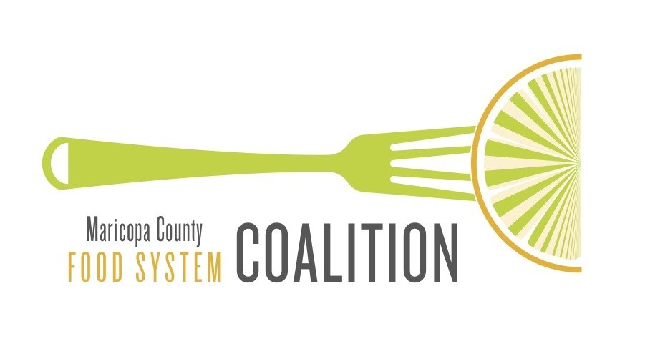
Issue Brief: COMPOSTING

MarCo Issue Brief - September 2021

Introduction

Composting

Compost is decomposed organic matter (i.e. yard waste, food scraps) that can be used as a fertilizer to improve soil health and nutrients. Composting is the fifth tier on the EPA’s Food Recovery Hierarchy.

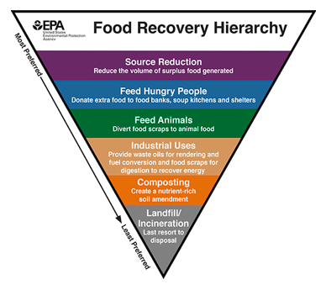

Benefits of composting:

- Reduces Waste – Rather than taking up space in the landfill, organic material such as yard waste and food scraps can be repurposed and used to enhance the soil we get our food from.
- Improves Soil Health – When compost is added to soil, the need for synthetic fertilizer decreases or is eliminated completely. With the help of compost, soil heath improves and can result in increased agricultural crop yields.
- Methane reduction – Organic waste in landfills generates methane, a greenhouse gas which contributes to climate change. Composting organic materials rather than throwing them out can greatly reduce the emission of Methane.
Types of composting
- Onsite Composting is best for households and small businesses who are looking to reduce small amounts of food waste and yard scraps. This generally involves a small composting bin or area and can take up to two years to produce compost.
- Vermicomposting utilizes Red Worms to break down food scraps, paper and yard trimmings. This type of composting must be done in a controlled environment (i.e. inside) and is generally done on a smaller scale.
- Aerated Windrow Composting is used for large amounts of organic material generated by large businesses or communities. This form of composting includes creating long piles of waste and periodic mechanical aeration.
- Aerated Static Pile Composting is also generally used for large amounts of waste. Rather than mechanical aeration, this method suggests mixing in a bulking agent (e.g. woodchips) to help with aeration.
- In-vessel composting can also accommodate large amounts of waste and generally is aerated mechanically in a container (e.g. silo, drum, trench). Using this method, a wide variety of organic materials can be composted in a relatively small amount of time.
Composting in Maricopa County
There are several ways residents in Maricopa County can become involved in composting and reduce the amount of waste in our landfills.
One of the easiest ways to compost is through the use of a curbside green yard waste container, which is offered by several municipalities in Maricopa County. For example, the City of Phoenix provides a low-cost yard waste container for residents to compost green organics (grass clippings, twigs, leaves, etc.). When this option is not available, or the volume of waste is too large, residents may choose to drop off their yard scarps rather than having them picked up. The City of Tempe offers this option, allowing residents to not only drop off compost materials, but also pick up compost to bring home.
While municipalities in Maricopa County are able to relieve some of the green/yard waste produced, they are not yet equipped to handle food waste. However, for residents wishing to reduce the amount of food waste that enters landfills, there are several options available.
First, many community groups and gardens are willing to take individual and household food waste. For example, The Orchard Community Learning Center allows for the drop off of both food and yard waste as well as the opportunity to purchase compost. This opportunity to compost is free and available to residents and businesses. Some community gardens also accept small amounts of compost materials from individuals and households, but it is best to call or visit before attempting to drop it off.
Another composting service available to all residents in Maricopa County is a food scrap pick up service offered by R.City. R.City provides composing buckets for residents, businesses and restaurants to dispose of food scraps for a small fee. Of course, residents may also choose to compost at their own home or business.
There are many resources for those who are interested in composing at home:
- Arizona Department of Environmental Quality compost guide: https://azdeq.gov/CompostGuide
- City of Phoenix Public Works Department Backyard composting guide: https://www.phoenix.gov/publicworkssite/Documents/pwd_pdf_compost_instructions.pdf
- U. S. Environmental Protection Agency composting resources: https://www.epa.gov/recycle/composting-home

There are important environmental, social, and economic benefits of composting. With so many opportunities and resources, individuals, households, and businesses in Maricopa County can successfully contribute to decreasing the negative effects of organic waste while enhancing soil quality.

Resources
Arizona Department of Environmental Quality. Compost guide.
https://azdeq.gov/CompostGuide

Natural Resources Defense Council. Composting 101.
https://www.nrdc.org/stories/composting-101

City of Phoenix. Composting in Phoenix.
https://www.phoenix.gov/publicworks/garbage/disposable/composting-and-green-organics

City of Phoenix Public Works Department. Backyard Composting.
https://www.phoenix.gov/publicworkssite/Documents/pwd_pdf_compost_instructions.pdf

City of Tempe. Solid Waste Compost Yard.
https://www.tempe.gov/Home/Components/FacilityDirectory/FacilityDirectory/240/1209?npage=6

Orchard Community Learning Center.
https://www.orchardlearningcenter.org/

R.City. Compost Services.
https://recycledcity.com/services/

United States Environmental Protection Agency. Composting at home.
https://www.epa.gov/recycle/composting-home

United States Environmental Protection Agency. Food Recovery Hierarchy.
https://www.epa.gov/sustainable-management-food/food-recovery-hierarchy

United States Environmental Protection Agency. Types of composting and understanding the process. https://www.epa.gov/sustainable-management-food/types-composting-and-understanding-process

